

**PRJ301**

**Assignment**

**PROJECT NAME: KIDS TOY STORE**

***Team Member:***

Đào Tấn Tỷ-SE140556

Phạm Thành Minh-SE14031

Nguyễn Hữu Tâm-SE140548

FPT University

# Case Study

U.C.Diagram

The web application allows users to view, book, adjust and view a kid toys. The users are categorized into three different groups, which can perform different tasks on the system.

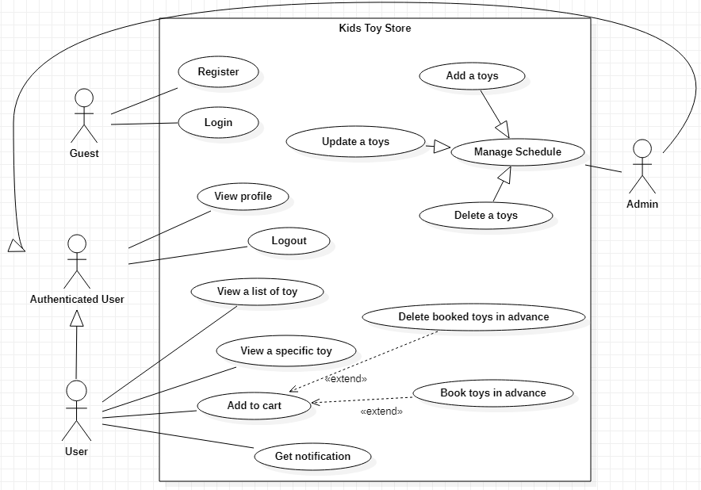

Specifications

**-*-Guest:**

**As a guest user, they can Login the system to get access authorized. If they are new to the system, they can Register for an account on the website.**

**-*-Authenticated:**

As an authenticated user, they can view their information so that the system manager can know who they are. From there they can edit their information.

**-*-Admin:**

As a system admin, they can view and edit the information of themselves just like an authenticated user.

They can manage the toys system by adding a toys, update a existing toys or delete a faulty toys. In addition, they can also view the booked and ban or unban a user from the system if the user violates the regulation.

**-*-User**:

As a user, they can also view and edit the information of themselves just like an authenticated user.

They can view all a list toys from there we can see the overall products. Moreover, if they like the product they can see the specific of those products.

In addition, they can also add to their cart the desired items of the store, from there they can pre-order those toys without fear of being out of stock or someone else buy them first. More than that, the pre-order that you want to change you can be deleted from the shopping cart.

# Database Design

## Database And Database Diagram

## Entity Relationship Diagram (ERD)

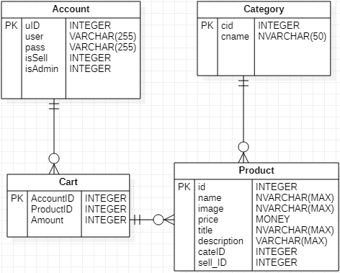

**Database**

ACCOUNT (uID, user, pass, isSell, isAdmin)

CATEGORY (cid, cname)

CART (AccountID, ProductID, Amount)

PRODUCT (id, name, image, price, title, description, cateID, sell_ID)

**Database Diagram**

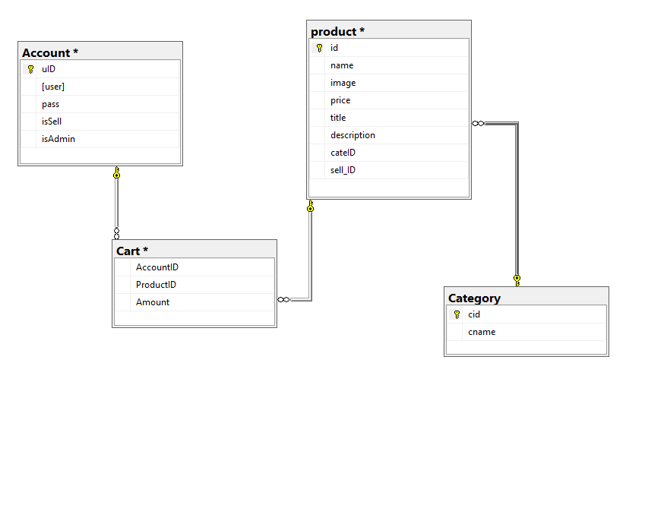

# System Design

**Class Diagram**

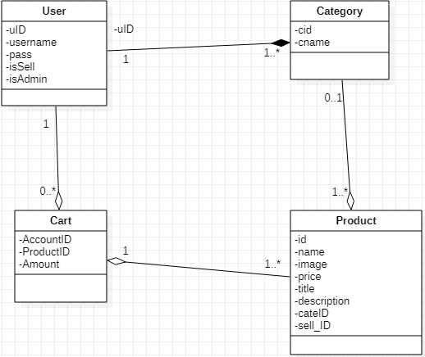

### Login Sequence Diagram

### SEQLOgin

### 

### Admin information-related sequence diagram

### 

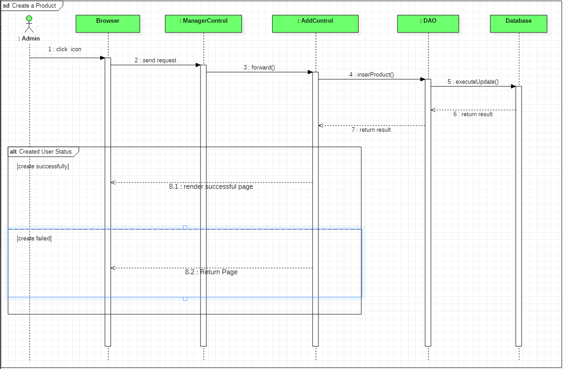

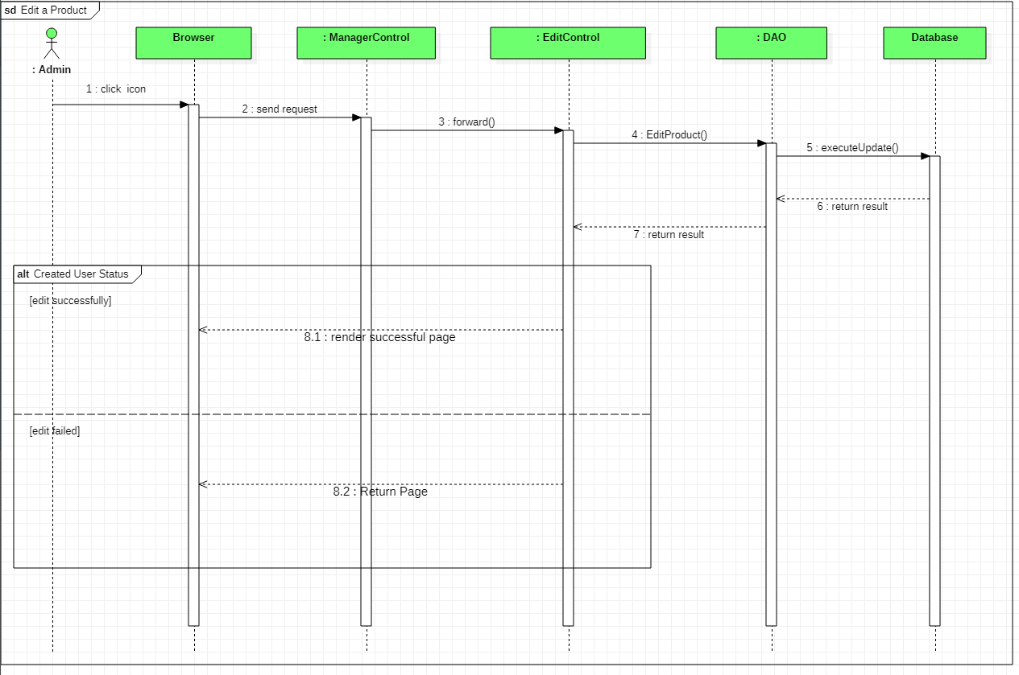

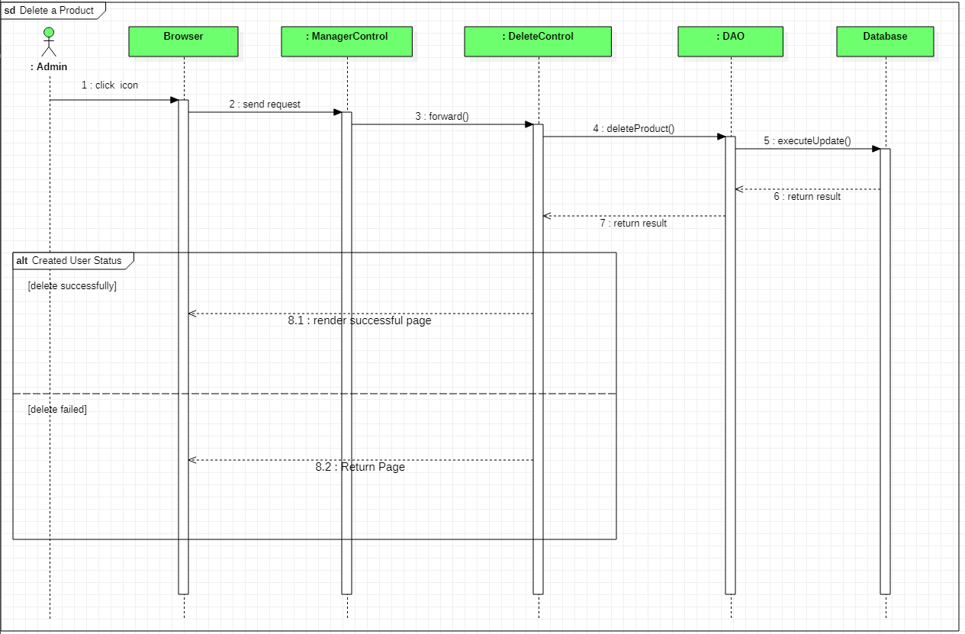

### User information-related sequence diagram

### **Vvvvv**

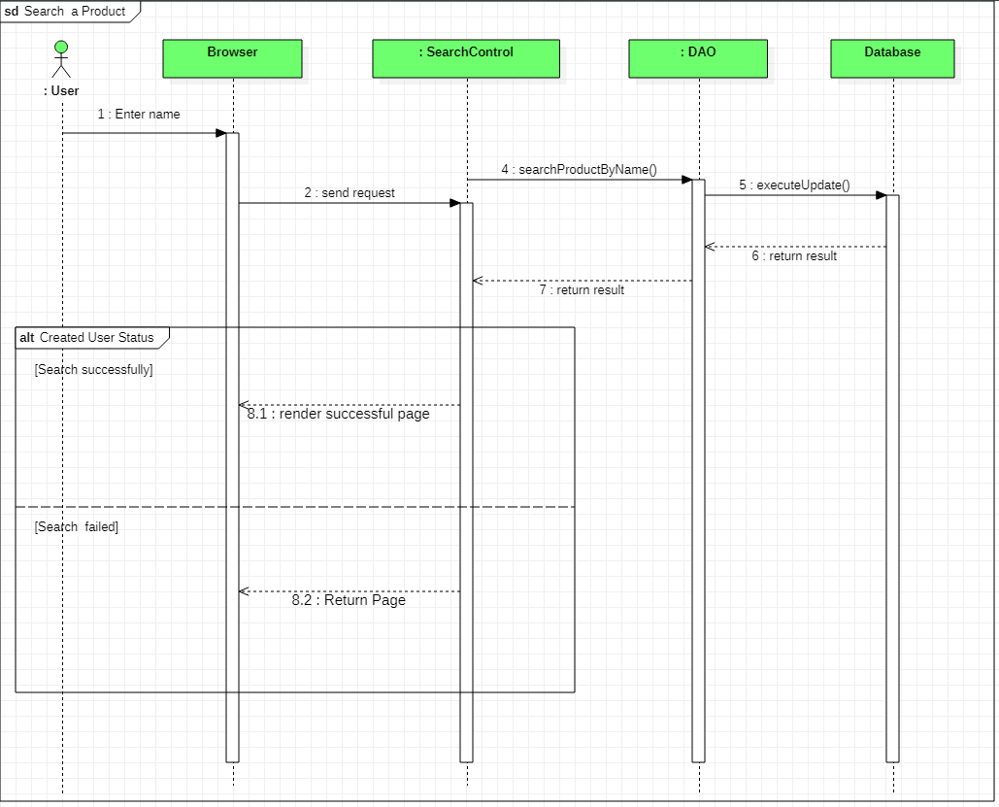

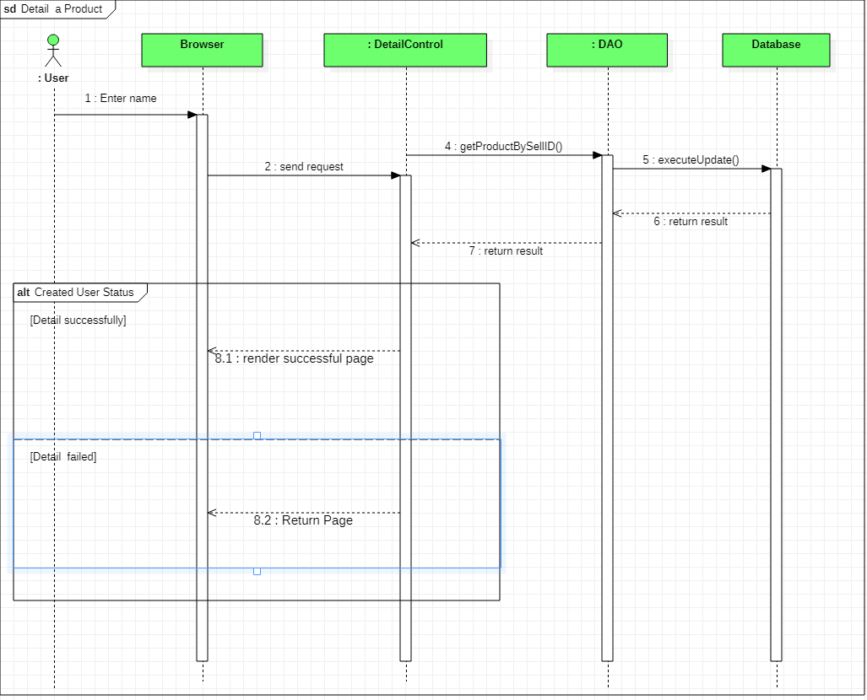

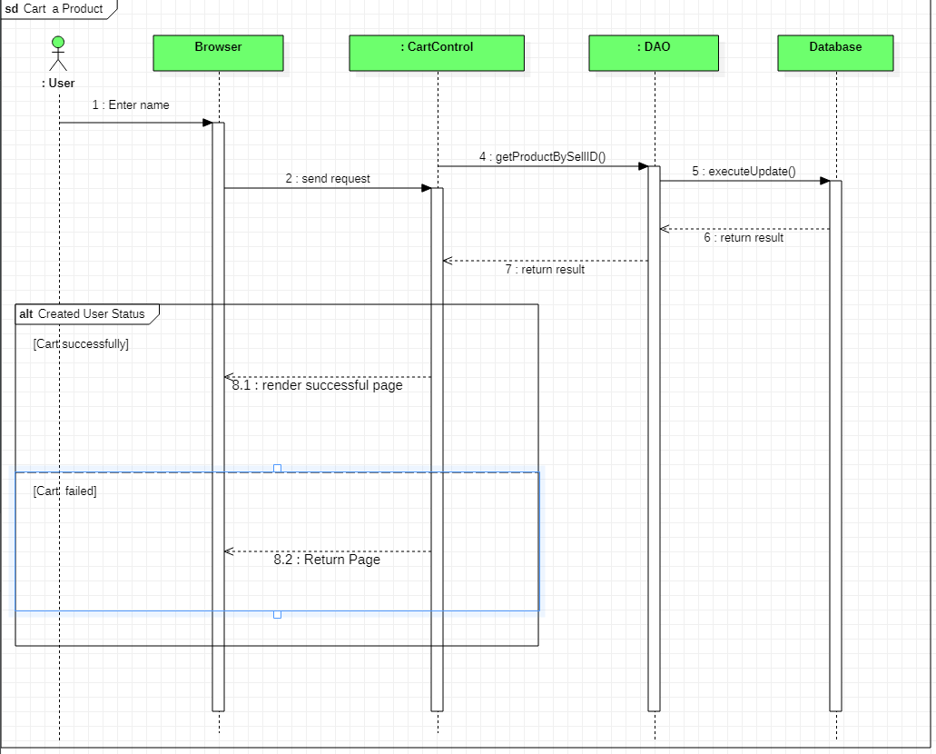

# Implementation (Screenshot with explanation)

\***Login and Create account**

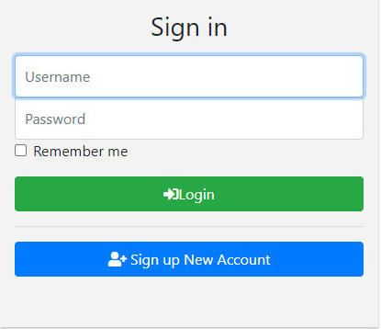 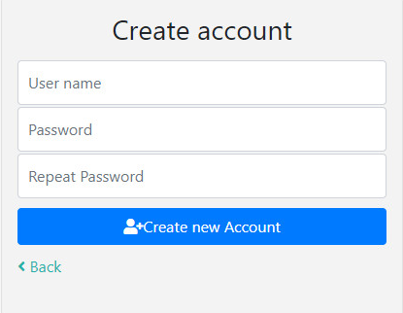

**Login /Create Fail**

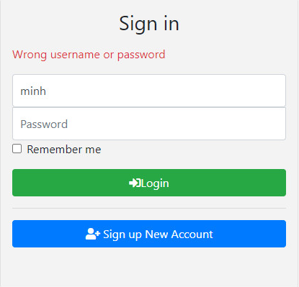

|  |  |  |
| --- | --- | --- |
|  | Successfull | Unsuccessful |
| Login | Successful login will be authorized to the homepage:  + If it is admin, it will be added to find delete / edit products.  + If the user is to see the products and product details. | An error message pops up |
| Create account | Go to home page and be defaulted as user | Return to the login page and display the error message |

\***Screen Home**

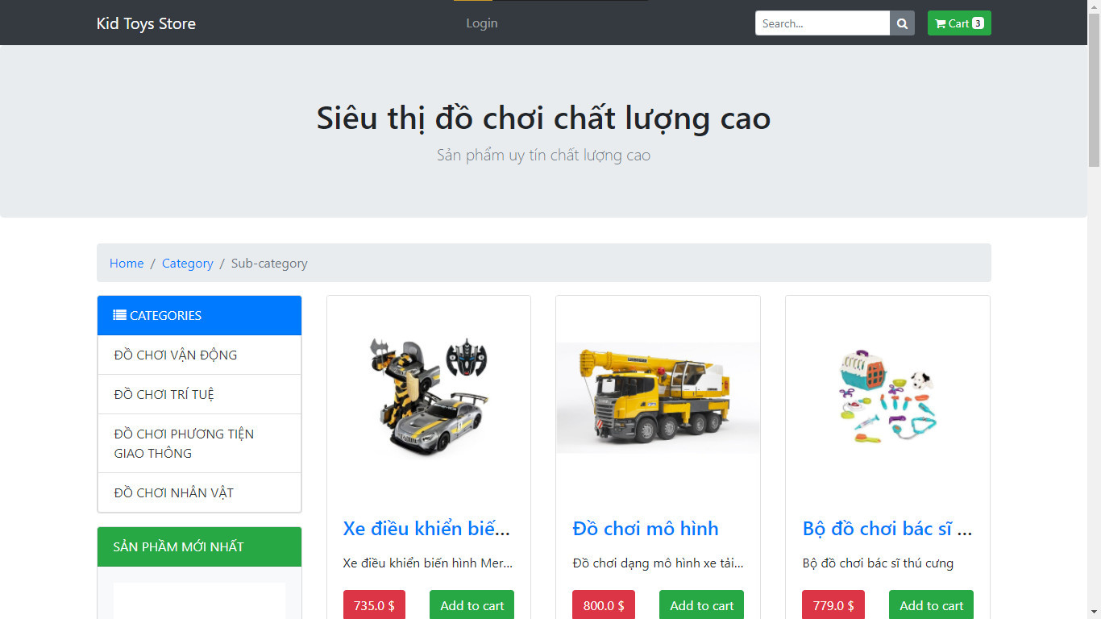

**Search Product**

There are 2 ways to find products:

+ Search by product name

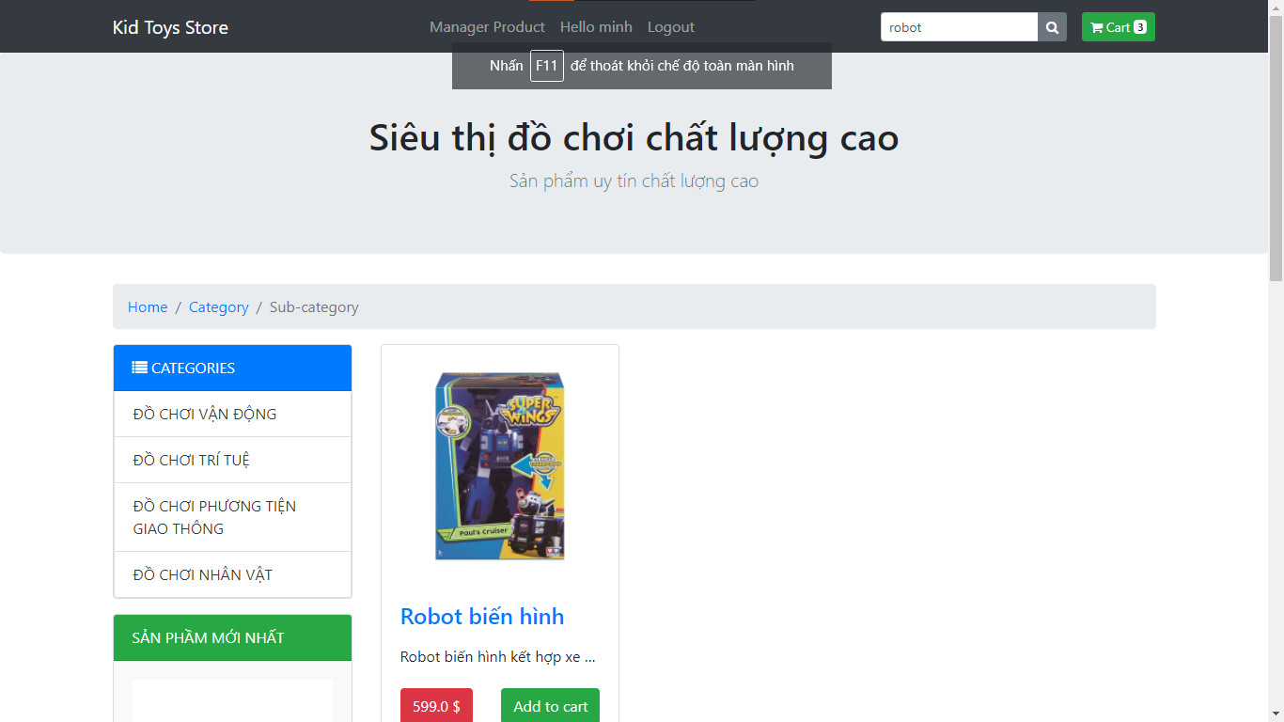

+ Search by product type

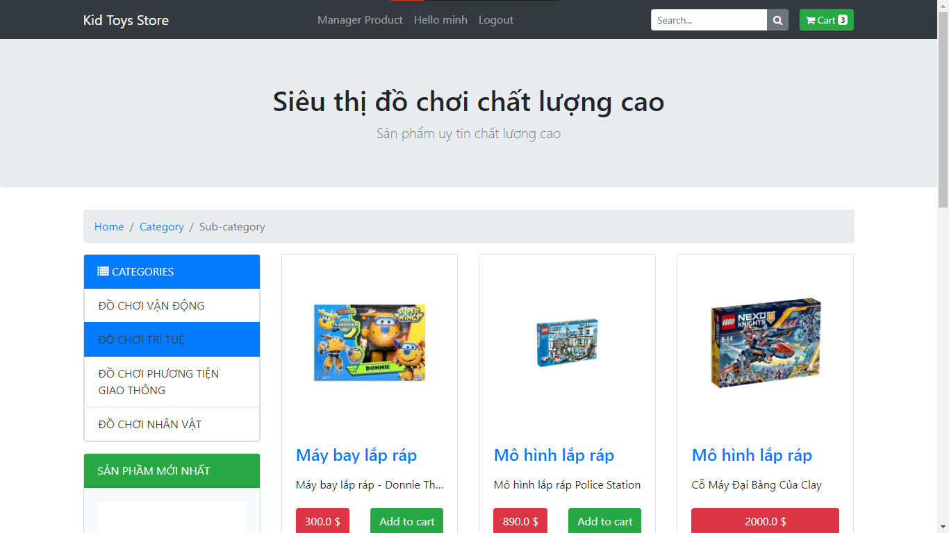

**Specific Product**

When you click on the product, details of the product will appear.

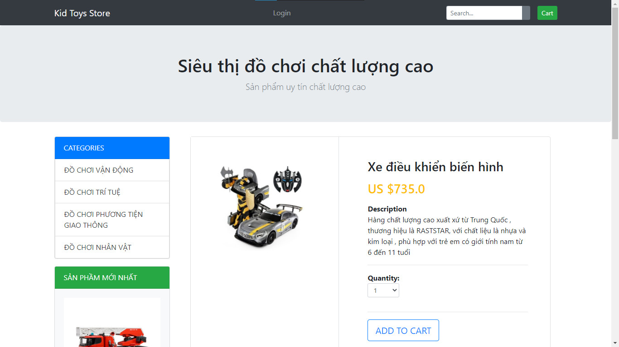

**\*Manage Product**

When logged in and authorized as admin, the admin will be able to manage the product (add, delete, edit)**.**

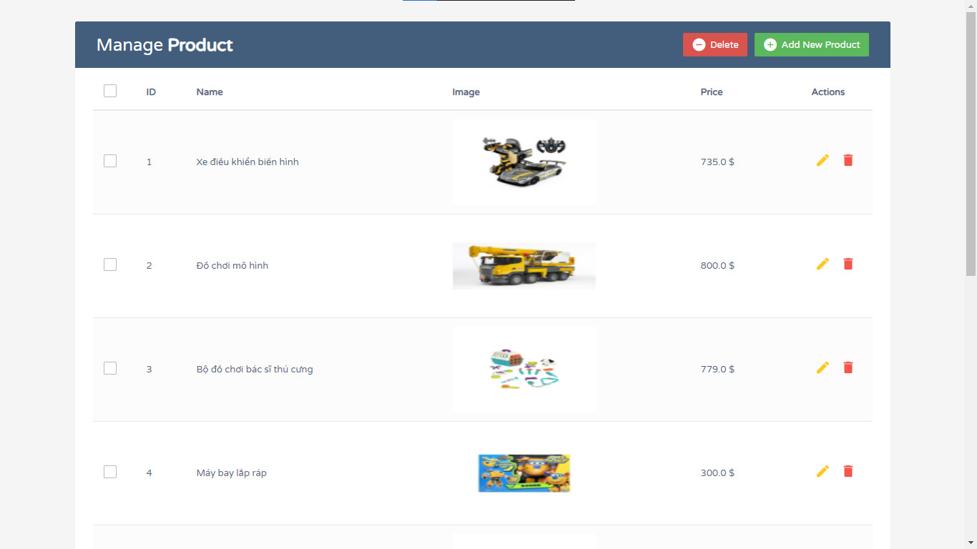

**Add Product**  **Update/ Delete Product**

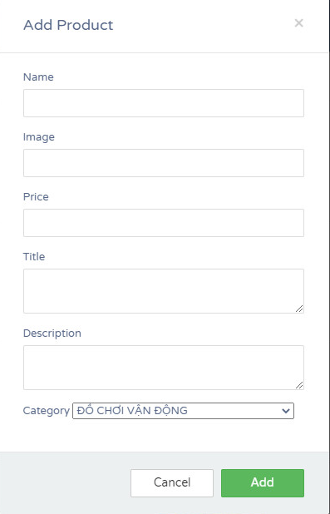 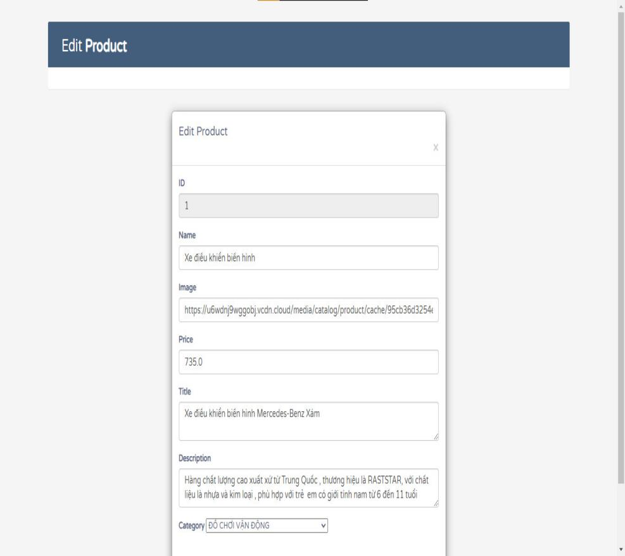

**Add Cart**

User added to the shopping cart purchased products.

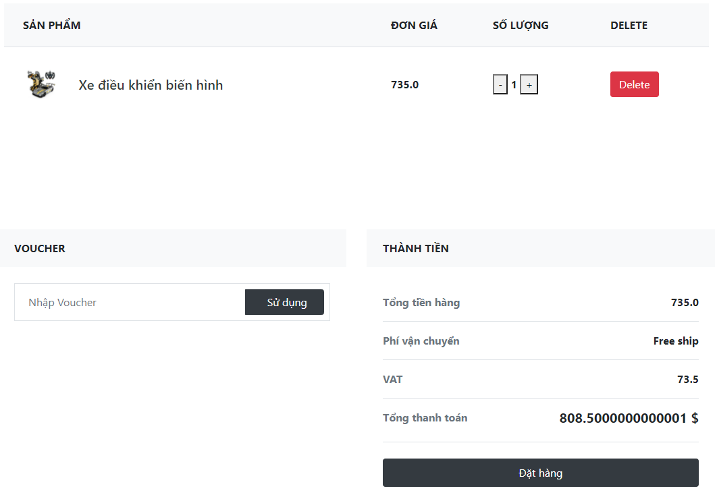

# Conclusion

**In the future, if we have more time, we will:**

+ For login, you can add login function with gmail and facebook.

+ Add messaging service between buyers and sellers via social networks.

+ Add online payment feature by Creadit Card and payment app.

+ Link with shipping application.

+ Add purchase history feature.

**Defect:**

+ No purchase history.

**Advantages:**

**+** Eye-catching product management interface

+ Product management for administrators is easy to use and simple to operate.

+ Easy account registration.

**About knowledge:**

+We have a better understanding of the **session** and **cookies** section.

+Have a better understanding of the 2 types of errors, **500** and **404** errors

**Error 500** occurs when data cannot be loaded.

**Error 404** occurs when erroneous recording and lack of transmission line.

# References

[1]. [https://startbootstrap.com/themes](https://startbootstrap.com/themes?fbclid=IwAR0RNDi4CHtUy91q3_oV3nGJwSugLBXE2tKxQufHbu_LwTeu8tQFvaVLtA8" \t "https://www.facebook.com/_blank).